Presentation by the Director of CMC

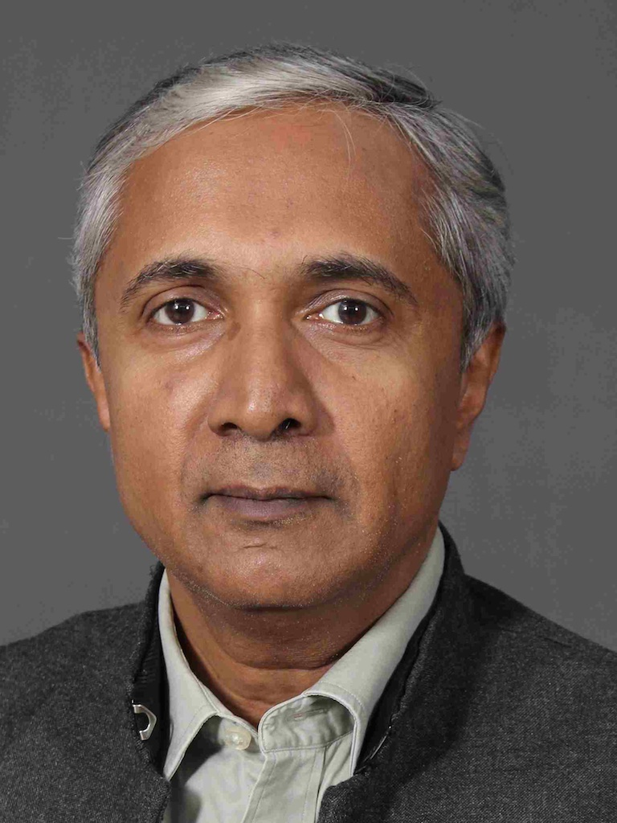

During his lightning visit to Australia in August, the Director, Dr Vikram Mathews, was able to attend the Annual General Meeting of the Australian Vellore Board. During the meeting, he gave a lengthy update on developments in Vellore and related areas, illustrating his report with a series of 80 informative slides. Some highlights of his presentation were as follows:
—There is much to be deeply thankful for. The institution has made a remarkable recovery since the depths of the pandemic, when it went through an existential crisis.
—The first full year including the fully functioning Ranipet hospital shows that the financial situation is recovering well, even if there are still loans to pay off. Numbers for outpatients, inpatients and surgeries are all up compared with the previous year.
—The plans for exciting new projects are taking shape: the Paediatric Speciality Center; the Pharmacy College Bagayam Campus; the Center for Public Health among others.
—Much renovation of existing sites is also taking place, including the creation of a greener campus and ecosystem.
—Developments at Chittoor: College of Nursing completed and ready for use; plans for a second Medical College together with a teaching hospital.
—The commitment to charity continues, with 10–14% reserved for work in this area. At Jawahdi Hills, in partnership with Don Bosco (who own the property), land has been earmarked towards the construction of a small hospital.
—For outreach the network of 168 Mission Hospitals and the connection through the mission portal is crucial. Many struggle, but there are also amazing achievements, for example at Madhipura in Bihar through the work of Dr Renu John and her partnership with Drs Arpit and Amy Mathew.
—Research also continues to flourish, with many achievements, not least in projects that are strongly contextual, carrying out research with practical applications.
—Many challenges remain, not least in the area of legal and regulatory issues. But the CMC remains a fine place to work. It is the people who are the key to its success.

